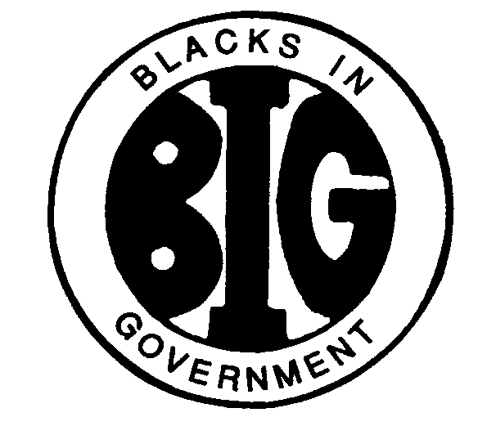

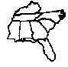

**REGION IV BLACKS IN GOVERNMENT**

***ALABAMA FLORIDA GEORGIA KENTUCKY MISSISSIPPI***

***NORTH CAROLINA SOUTH CAROLINA TENNESSEE***

Executive Committee Meeting

## BYLAWS COMMITTEE REPORT

**October 7, 2024**

Names: Al Taylor, Magnolia Chapter (Chair); Famous Johnson, East Central Savannah River Chapter and Arnold Taylor, First Mississippi Chapter

E-Mail Address: queart2@aol.com

Cell Phone: (601) 201-1528

1. **RESPONSIBILITIES**

The Bylaws Committee shall render constitutional opinions to the Executive Committee and the Regional Council; shall periodically review the Regional Bylaws and the National Constitution and recommend amendments where appropriate; shall offer opinions on the constitutionality of all policies; and shall be responsible for incorporating all approved amendments into the Regional Bylaws and distribute them to the Chapters within thirty (30) days through the Regional Council President.

1. **ACTION ITEMS**

There are no action items from the committee currently.

1. **ACTIVITIES**

Bylaws amendments approved at the June 8, 2024, council meeting were incorporated into the Region IV bylaws and forwarded to the Region IV Council President for appropriate signatures along with a memo calling for proposed amendments for the Fall Council Meeting.

1. **INVITATIONS & EVENTS**

There are no pending invitations or events.